Python Program to Print all Integers that Aren’t Divisible by Either 2 or 3 and Lie between 1 and 50

for i in range(0,51):

  if(i%2!=0 and i%3!=0):

    print(i)

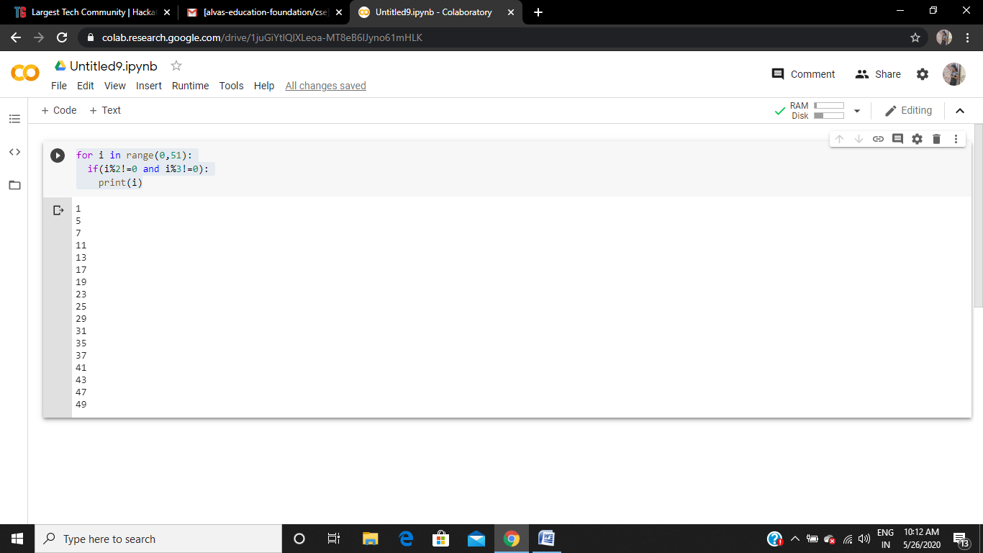

Python Program to Check if a Number is a Palindrome

n=int(input("Enter number:"))

temp=n

rev=0

while(n>0):

    dig=n%10

    rev=rev*10+dig

    n=n//10

if(temp==rev):

    print("The number is a palindrome!")

else:

    print("The number isn't a palindrome!")

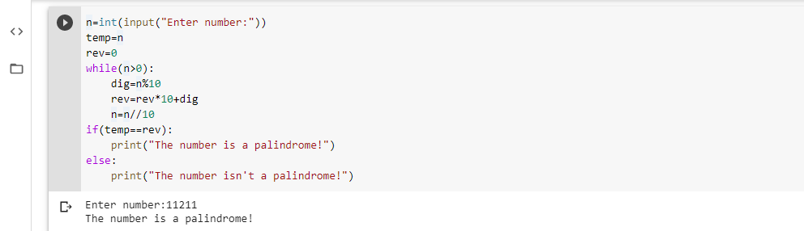

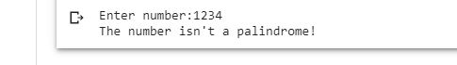

Python Program to Count the Number of Digits in a Number

n=int(input("Enter number:"))

count=0

while(n>0):

    count=count+1

    n=n//10

print("The number of digits in the number are:",count)

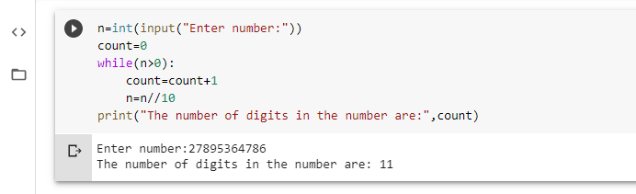

Python Program to Read a Number n And Print the Series "1+2+…..+n= "

n = int(input("Enter a Number : "))

series_sum = []

for i in range(1,n+1):

 series_sum.append(i)

 if i==n:

    print(i, end='')

 else:

    print(i,end=' + ')

print(' = ', sum(series_sum), sep='')

